A.B. Daley Professional Learning Communities 2018-2019

Area of Focus: Enhancing deep learning through play

What school goal does it support or relate to? Literacy, Numeracy, Success for all Learners

PLC Members (max 4) : Alli Martin, Jill Spencer, Jessica MacPherson

What does your group hope to accomplish during your PLC time?
-Develop centers in the learning commons that provide an element of wonder, play, exploration that is connected to learning (writing centers)
-Develop outdoor experiences that foster deep learning

Order tinker trays, shelf, (rocks, wood, tinker items) (buckets, shovels-outdoor) Snow shovels.
Writing Checklists color coordinate them.

What steps do you need to take in order to accomplish this goal? (Supports/Strategies)

-Research inquiry/ wonder and it’s benefits for deep learning across all grades (Webinar? Book Study? PD?)

-take action on our research (Conversations with staff, determine what materials we’d need, make a budget etc. etc.)

How will this information be used to enhance student learning?

Through implementation of centers for example, students will experience deep learning that connects to competencies.

List any resources you will need (i.e. book study)
https://go.fairydustteaching.com/wonder-teaching-tribe/
(More resources to come as we research)

Writing Continuum

What two half days would you like sub coverage/admin coverage for? (not Fridays please)... maybe list a few extra dates just in case multiple people want the same date

Tuesday December 11, 2018

How will you share what you are learning with staff?

Staff Meeting
Email
Model use of centers for classes

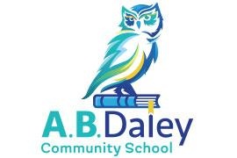

Learning Commons Centers

